Job Application Tracking System

**5 tips on creating a brand new job for yourself**

1. Put your personality forward.
2. Don't wait to be asked.
3. Sharpen your elevator pitch.
4. Be a considerate networker.
5. Getting hired is just the beginning.

# **Create and Configure Jobs**

## Learning Objectives

After completing this unit, you’ll be able to:

* List three tasks you can perform with the Jobs module.
* Create a job.
* Assign resources to a job.
* Add a job step to one or more flows.
* Create a global parameter.

## Introduction

Now that Linda understands jobs and knows about system and custom job steps, it’s time for her to create and configure a job. She needs access to the Business Manager Jobs module to do this. The Jobs module lets her create and schedule jobs, set up email notifications for job failures, and use job resources to prevent conflicts.

To access Business Manager, you must have a B2C Commerce implementation. In this module, we assume you are a B2C Commerce administrator with the proper permissions to perform these tasks. If you’re not a B2C Commerce administrator, that’s OK. Read along to learn how your administrator would take these steps in a staging instance. Don't try to follow our steps in your Trailhead Playground. B2C Commerce isn't available in the Trailhead Playground. If you have a staging instance of B2C Commerce, you can try out these steps in your instance. If you don't have a staging instance, ask your manager if there is one that you can use.

## Create the Job

Here’s how Linda creates a job to import a catalog.

1. Open Business Manager.
2. Select **Administration > Operations > Jobs**.
3. Click **New Job** (1).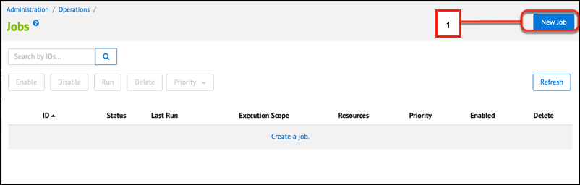
4. Enter cloudkicks-catalog-data as the ID (1) and Catalog data for Cloud Kicks as the Description (2).
5. Ignore the Priority feature. It’s not supported at this time.
6. Click **Create** (3).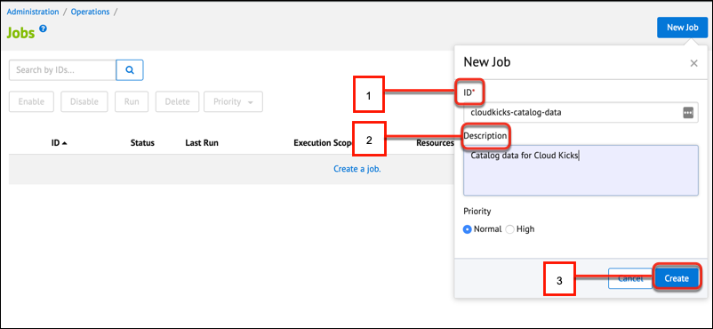
7. Click the **Schedule and History** tab.
8. Select **Enabled** to run the job on a schedule. If the job isn't enabled, you can still trigger it manually.
9. Select **Once** to trigger the job to run once, or select **Recurring Interval**.
10. For jobs that you want to run on a recurring interval, use the calendar icon to select a date in the past. If you don’t schedule a date in the past, you have to wait for the date you specified for the job to run. You can also select a day of the week, a time, an interval, and a number of times the job should run.